Case Analysis – Hurtigruten: Sailing into Warm Water?
Student’s Name:
Institutional Affiliation:
Course Code and Name:
Professor’s Name:
Date of Submission:

Market Analysis for expedition cruises
Porter’s five forces
Introduction
Porter's five forces model was established by Michael Porter. According to Chartered Global Management Accountant (2013), this model is mainly used when analyzing the competitive environment of businesses, organizations, or a company. Porter's five forces include; buyers, suppliers, competitors, substitutes, and potential entrants.
Buyers. The buyers of the services offered by Hurtigruten are the expedition tourists in the polar regions of Scandinavia. Some came from Europe, North America, and Australia (Rivkin & Herman 2020). Hurtigruten's determination is to explore expeditions and sail to other warm water regions. Since most of its customers are tourists who are explorers, sailing to warm water areas will increase its customers' capacity because they will be able to move to other areas to explore.
Suppliers. The company sourced their foods from local ports located in their route under the new leadership of Daniel Skjeldam as the CEO (Rivkin & Herman 2020). Hurtigruten procured their ships from designers and shipyards and expanding their vessels.
Competitors. The expeditions cruise industry is packed with at least 113 competitor companies (Rivkin & Herman 2020). Ponant and Lindblad are among the top competing companies with many ships. Even though the number of service buyers is large, the level of competition is also very high.
Substitutes. The major substitute for the cruise ship expedition fleet is air travel. Although, they play a lesser significant role since they cannot offer the experience and feeling of adventures when traveling on water, and the scenery is different.
Potential Market Entrants. The 2021 projection shows 113 ships from different companies (Rivkin & Herman 2020). This is an indication that in the future there will be a significant increase in the number of ships and companies in the industry. For instance, the number of ships is projected to increase unanimously by 2024, from over 73 ships counted in 2018. Thus, there is room for potential market entrants in the future.
The analysis of porter’s five forces model reflects the available opportunities for Hurtigruten company to endeavor if the company expands sailing to warm water regions (Rivkin & Herman 2020). Hurtigruten also needs to have a proper marketing strategy because of the existing threats from the new and existing companies, and substitutes. However, the projected capacity share for both warm water and polar expeditions shows Hurtigruten having the greatest share by 2021.
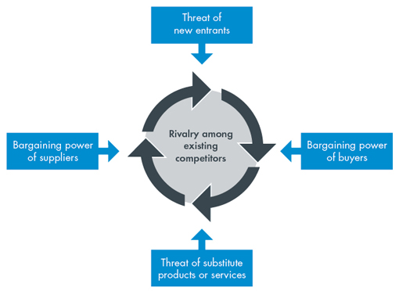
https://www.cgma.org/content/dam/cgma/resources/tools/essential-tools/publishingimages/porters-five-forces.jpg

SWOT Analysis
Strengths  - Good leadership led by Daniel Skjeldam  - Ability to source cheap supplies  - Digitalization of services and,  - Possession of large-sized cruise ships (Rivkin & Herman 2020). | Weaknesses  - The inability to offer a consistent luxurious experience in hotel operations.
Opportunities  - Opportunity to explore new markets by sailing into warm water expeditions.  - The arrival of new technology will allow Hurtigruten to design luxurious ships that carry large capacity. | Threats  - Current stiff competition from over 113 cruise ship expedition from different companies (Rivkin & Herman 2020).  - Projected stiff competition, with a projected increase of 39 polar expedition cruise ships in the next five years.

References
Chartered Global Management Accountant (2013). Porter’s Five Forces of Competitive Position Analysis. Retrieved from: https://www.cgma.org/resources/tools/essential-tools/porters-five-forces.html
Rivkin. W. J & Herman. K (2020). Hurtigruten: Sailing into Warm Water?

